



**Module Code & Module Title**

**CS5004NI Emerging Programming Platforms and Technologies**

**Assessment Weightage & Type**

**30% Group Coursework**

**Year and Semester**

**2018-19 Autumn**

|  |  |  |  |
| --- | --- | --- | --- |
| **Group Name: Laptop GanG** | | | |
| **SN** | **Student Name** | **College ID** | **University ID** |
| **1** | **Rajat Shrestha** | **np01cp4a170021** | **17030954** |
| **2** | **Pranav Khatri** | **np01cp4a170210** | **17031046** |
| **3** | **Nikolas Shrestha** | **np01cp4a170150** | **17031243** |

*I confirm that I understand my coursework needs to be submitted online via Google Classroom under the relevant module page before the deadline in order for my assignment to be accepted and marked. I am fully aware that late submissions will be treated as non-submission and a mark of zero will be awarded.*

# Proposal

This proposal is to address the first coursework assigned as group work in Emerging Programming Platforms and Technologies module which involves designing and developing an Information System. For this project, an Information System dealing with laptops was finalized as it seemed more reasonable as a laptop will have various attributes which user might be searching for. This information system will implement the concept of binary search algorithm to find the specific product within its inventory. This project will also include GUI for dealing with adding and searching the items for better user experience. The completed information system will have a various set of features and how the user can interact with various pieces of information regarding the laptop. The list of features and data dealt by this system are as follows:

### List of data:

1. **Serial Number** (Integer) It assigns the laptop according to its entry.
2. **Manufacturer** (String) It will describe the manufacturer of the laptop.
3. **Model Number** (String) It will give the unique model number of the device.
4. **Screen Size** (String) This determines the display size of the laptop.
5. **Processor** (String) This determines the processor of the laptop.
6. **RAM Size** (String) This determines Memory size of the laptop.
7. **Storage Size** (Integer) This determines Storage capacity of the laptop.
8. **Price** (Integer) This will give the price of the laptop.

### List of features:

* GUI is designed to enhance the user experience,
* The system will contain 12 unique items at the beginning,
* New products can be added to the table,
* Object-Oriented Programming technique is used to store the products,
* The array list is used as a data structure,
* A binary insertion sort algorithm is used to sort products according to price,
* Data of each product will be stored in a table and Array lists,
* The items are sorted while stored in an Array lists,
* Products can be searched according to category or price,
* The binary search algorithm is used to find products by the price.
* Invalid inputs are not accepted and users are notified about it,
* The code will have implemented exception handling feature for seamless running.

### Tools used

To create this project various tools are needed to be used for designing, planning, and developing which are:

* Sublime text: A simplistic text editor to edit texts and codes.
* Microsoft Word: Word processing software to create professional and formal documentation of the designing, planning, and reporting the development process.
* Net-Beans IDE: A well-integrated development environment of Java which simplifies the task of designing and creating the GUI.
* Affinity Designer: A simple but powerful tool for creating elegant vector graphics and editing pictures.

Table of Contents

Individual Task 1

Introduction 2

Binary Search Algorithm 3

1. Flow-Chart: 4

2. Implementation of the program: 5

Pseudocode: 5

3. Sorting 6

Flowchart for modified Binary search to return index 7

Method Description 8

Testing 11

1. Running in NetBeans: 11

2. Adding an Item: 13

3. Searching by Category (Screen-size): 15

4. Searching by Price: 17

5. Exception Handling: 19

6. User Input Error Handling 21

7. Checking the functionality of other features: 24

Conclusion 29

References 31

Appendix 32

1. The limitations of the binary search algorithm: 32

2. Detailed method description for the binary search: 33

3. Method for modified binary sort : 34

4. Insertion technique 35

User Guide 36

**Table of Figures:**

Figure 1: Flow-Chart for Binary Search Algorithm 4

Figure 2: Flowchart for binary search to return index for the new products 7

Figure 3: (Test 1): Importing Project File 11

Figure 4: (Test 1): Running the GUI class 12

Figure 5: (Test 1): Find Your Laptop Running 12

Figure 6: (Test 2): Entering data 13

Figure 7: (Test 2): Message pops up after adding 14

Figure 8: (Test 2): Item added in the table 14

Figure 9: (Test 3): Searching by category, selecting 15 inch 15

Figure 10: (Test 3): Displaying all 15-inch laptops 16

Figure 11: (Test 3): Similarly, displaying all 17-inch laptops 16

Figure 12: (Test 4): Searching for a laptop by price 40000 (With multiple entries) 17

Figure 13: (Test 4): Searching for a laptop by price 210000 (With Single entry) 18

Figure 14: (Test 5): Error due to empty fields which require integer input 19

Figure 15: (Test 5): Error due to higher than the highest price in a search by price 20

Figure 16: (Test 5): Error due to string input in place of integer 20

Figure 17: (Test 6): Error due to Empty Fields 21

Figure 18: (Test 6): Error due to missing screen-size details 22

Figure 19: (Test 6): Error due to missing price 22

Figure 20: (Test 6): Error due to missing processor details 23

Figure 21: (Test 6): Error due to duplicate value for a model number 23

Figure 22: (Test 7): Unwanted user input to be cleared 25

Figure 23: (Test 7): Pressing Clear Button 25

Figure 24: (Test 7): Clearing using Menu item Clear option 26

Figure 25: (Test 7): Cleared User input due to the Clear action 26

Figure 26: Sorting the laptops according to the screen-size 27

Figure 27: Sorting according to the manufacturer 27

Figure 28: Selecting open documentation option 28

Figure 29: The PDF document opens 28

Figure 30: (Test 7): Checking the close option 29

Figure 31: Program terminated due to close action 29

Table of tables:

Table 1: Method Summary for FindYourLaptop class 8

Table 2: Method Summary for laptop object 10

Table 3: (Test 1) Running in NetBeans 11

Table 4: (Test 2) Adding an item 13

Table 5: (Test 3) Searching by category 15

Table 6: (Test 4) Searching by price 17

Table 7: (Test 5) Exception Handling 19

Table 8: (Test 6) User Input error handling 21

Table 9: (Test 7) Other Features checking 24

# Individual Task

To complete the following project, every group member has contributed equally while designing, developing, testing and documenting the entire process. To complete this project the following steps are essential to be done:

1. Analyzing the requirement of the project,
2. Creating a design prototype consisting of GUI elements,
3. Making the components function,
4. Using a data structure to store the data,
5. Sorting the data stored,
6. Implementing Binary Search on the sorted data.

The group consists of three members and the task load was divided equally among three members. The responsibilities divided into each individual while working on this project is listed as follows:

**Rajat Shrestha:**

Analyzed the requirements of the project and identified the key functionality. Suggested to store the data in an array list composed of the custom object. Researched about binary search and created a flowchart to represent the logic clearly. Specified and documented the testing process.

**Nikolas Shrestha:**

Created a GUI structure to make a platform for the functionality. Made the custom object with all the required accessor methods. Discussed how the binary search algorithm could be used in the program and written detailed pseudocode. Did the testing in the actual program.

**Pranav Khatri:**

Initializing the document by writing a proposal and listing all the data used and features in the program. Implemented the insertion sort to store the object as data in an array list. Converted the pseudocode into the code and made the search button functional. Added various small features in the program.

# Introduction

This document clarifies the information System developed which deals with laptops in which a user can add, store or find the desired product. This program contains various elements and programming techniques to function properly and is created in a modular manner so that it can be configured or debugged easily. The modularity of this program will allow this program to reuse the same code at multiple instances, which is much more efficient. The program will also store the product data for each laptop as a laptop object in array lists for storing, sorting and searching. The GUI is created by implementing included java library dealing with all sorts of GUI component called “Java Swing”. The selection sorting algorithm is used to sort the data individually while being added to the program. The sorted information will be crucial to search the product with respect to its price.

Graphical User Interface (GUI) is simply a method of delivery of data to the user in a user-friendly manner (Hopping, 2018). User Experience (UX) design deals with creating user interfaces (GUI) that provides easy and relevant experience to users who will use that program (The Interaction Design Foundation, 2018). Java Swing package is a pre-installed java library which provides a basic set of light-weight GUI elements to create small to big projects that implement GUI and often call ActionListener class to ensure functionality (Oracle , 2019). To create the project including buttons and other interactable components the main class is extended from the ActionListener class which will handle different user-defined actions. Various components such as buttons, labels, text-fields, combo-boxes, menu-items, radio-buttons, panel and table are used for the creation of GUI and pop-up boxes linked to different actions to interact with the user.

The object-oriented method of programming involves detailed specification of objects rather than logic and commands so that these objects can have defined attributes and functions which will make it easier to manipulate and handle these objects to solve various scenarios. Data Structures is simply a format for storing data (Rouse, 2014). The data structure used for this project is Array-list because it can also store various objects, simple syntax, easier methods and adjustable size (Jacobson & Thornton, 2004). Sorting is simply arranging a set of similar data in a specific order the sorting algorithm used in this system is Selection Sort which is a linear sorting algorithm (Mahmoud, 2011). The program will utilize this sorted data to search any product with respect to its price using Binary Sort Algorithm.

# Binary Search Algorithm

Also known as log arithmetic search or half-interval search, it requires a sorted data-structure to work on unlike a linear searching algorithm (Williams Jr., 1976). The binary search algorithm directly compares the middle index to the search term and if the value is equal it will return the index of the middle term. If the search term is bigger or smaller than the search term then it will divide the sorted data into smaller parts and begins the whole procedure again on the divided half (Weisstein, 2018). In this case the binary search is utilized so that the product can be searched by its respective price. In terms of efficiency the binary search can be described as an algorithm with logarithmetic time complexity of “O(log n)”. Time complexity is simply the measurement of the efficiency of the program with respect to time required to do certain number of operations (Lai, 2018). So theoretically this algorithm will work well on large amount of data. However this algorithm is designed to access only a single product every time so the other product with the same price is ignored. This problem can be easily be solved by implementing a separate linear search algorithm to search for product with the same price within its proximity but the scenario states that only a single product to be displayed so the other products are ignored. (The limitations are discussed in the appendix.)

The Binary search algorithm used for searching the items is designed as a recursive method which utilizes tail recursion. Recursive methods are simply a method which will call itself until it satisfies a condition and terminates itself. In this case the binary search can be made functionally recursive by calling itself if the middle term isn’t equal to the search term, the binary search is called again and again until it find the respective item or exhausts out of products. Tail recursion is the type of recursive function in which the method is called after some operation is completed (baeldung, 2018). In this case the method will compare the values before calling itself. The recursive nature of this code helps this algorithm to be easier but the recursive method might require more memory. The binary search algorithm designed for searching the products by price can be understood more clearly by the following flowchart below:

## Flow-Chart:

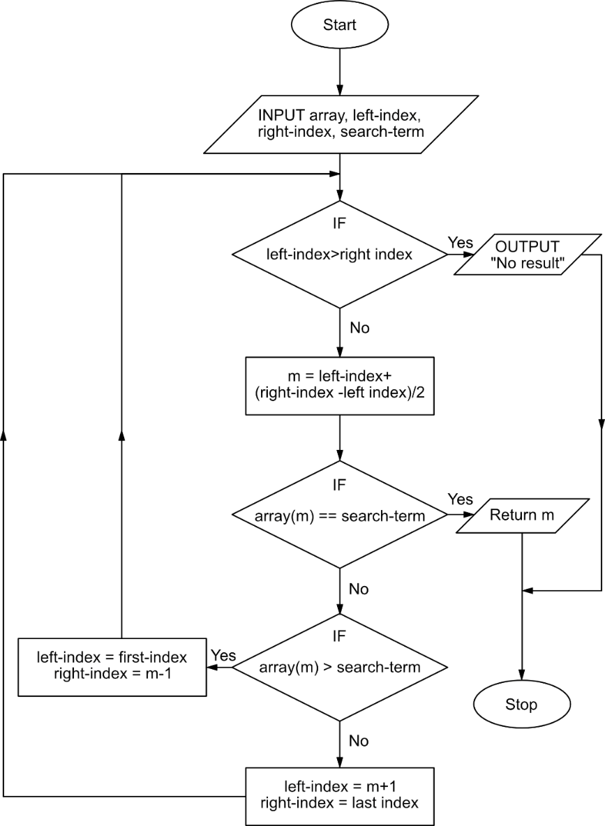

Figure 1: Flow-Chart for Binary Search Algorithm

## Implementation of the program:

To use the principle of binary search in the program to search any product according to their price, two sorted array lists were created in which the products were sorted according to their price. In the first array list, price sorted laptops were stored while the other array list contained only the prices of the products in it. These two array lists have the same product stored within them so that when we take the index from the price array list to the product array list the product is mapped. (The java method is discussed further in the appendix.)

Then to search the product according to their price the price array list is taken with only sorted data in form of an integer and is put through the binary search algorithm along with the search term. The first and last index info is also passed as a parameter so that at the program will know the range in which it will have to search for the term. If the product with that price doesn’t exist the program will notify the user about the error. The pseudocode for the method and method calling is as follows:

### Pseudocode:

**METHOD** **binarySearcher**(*ArrayList, FirstIndex, LastIndex, SearchTerm*)

**IF** (*FirstIndex* **<=** *LastIndex*)

*MiddleIndex* **=** (*LastIndex* - *FirstIndex*)*/2* + *FirstIndex*;

*MiddleValue* **=** VALUE(*MiddleIndex*);

**IF** (*MiddleValue* **==** *SearchTerm*){

**RETURN**(*MiddleIndex*);

**ELSE IF**(*MiddleValue* > *SearchTerm*)

**RETURN**(**binarySearcher**(*ArrayList, FirstIndex, MiddleIndex-1, SearchTerm*));

**ELSE**

**RETURN**(**binarySearche***r*(*ArrayList, MiddleIndex+1, LastIndex, SearchTerm*));

**NOTIFY** ("Not found")

**CALL METHOD** **binarySearcher**(*price, 0, price.length*()*, searchPrice*)

## Sorting

As binary search requires the data to be sorted the sorting was also implemented in this information system so that no problem will arise while searching for any product. As the information system consists of predefined products and also supports addition of the items, it is best to sort the items while sorting than to sort every time binary search is invoked to search for certain product. So the best method for sorting the values is by insertion method so that a data being added to the information system will be sorted according to the price. So to insert the new data, the index for the new data should be specified. So to find the new position for the new data is determined by using a modified binary search algorithm. This binary sort algorithm will determine the new position for the new data with all the benefits of algorithm with logarithmic time - complexity (O(log n)). The binary search algorithm used for sorting is a little different and has to return the index so it is a little different than the binary search algorithm previously discussed. This binary search is based on iteration instead of recursive functionality. The iterative method will make this binary search method more memory efficient than the previous recursive method.

This binary search will work by initially by checking if the new value to be added is between the two extremes of the sorted array. If the new value is smaller than the smallest value in the list of sorted data, it will return “0”. If the new value is bigger than the biggest then it will return “-1”. Then if the value is within the range then it will start iterating the various binary search steps to determine the exact new index for the new value and return that particular index. This binary search algorithm is further discussed in the flowchart.

As the binary search determines the position of the new element the insertion mechanism for this information system will first add any value to the array lists if it is empty. If the array lists are not empty it will then take the index calculated by the binary search algorithm and add the new products accordingly. If the binary search returns “-1” then it means that the new product has the price higher than the highest value in the current sorted array list so it will simply append the data to the last of the array list. The flowchart for the binary search utilized for returning the index is as follows:

### Flowchart for modified Binary search to return index

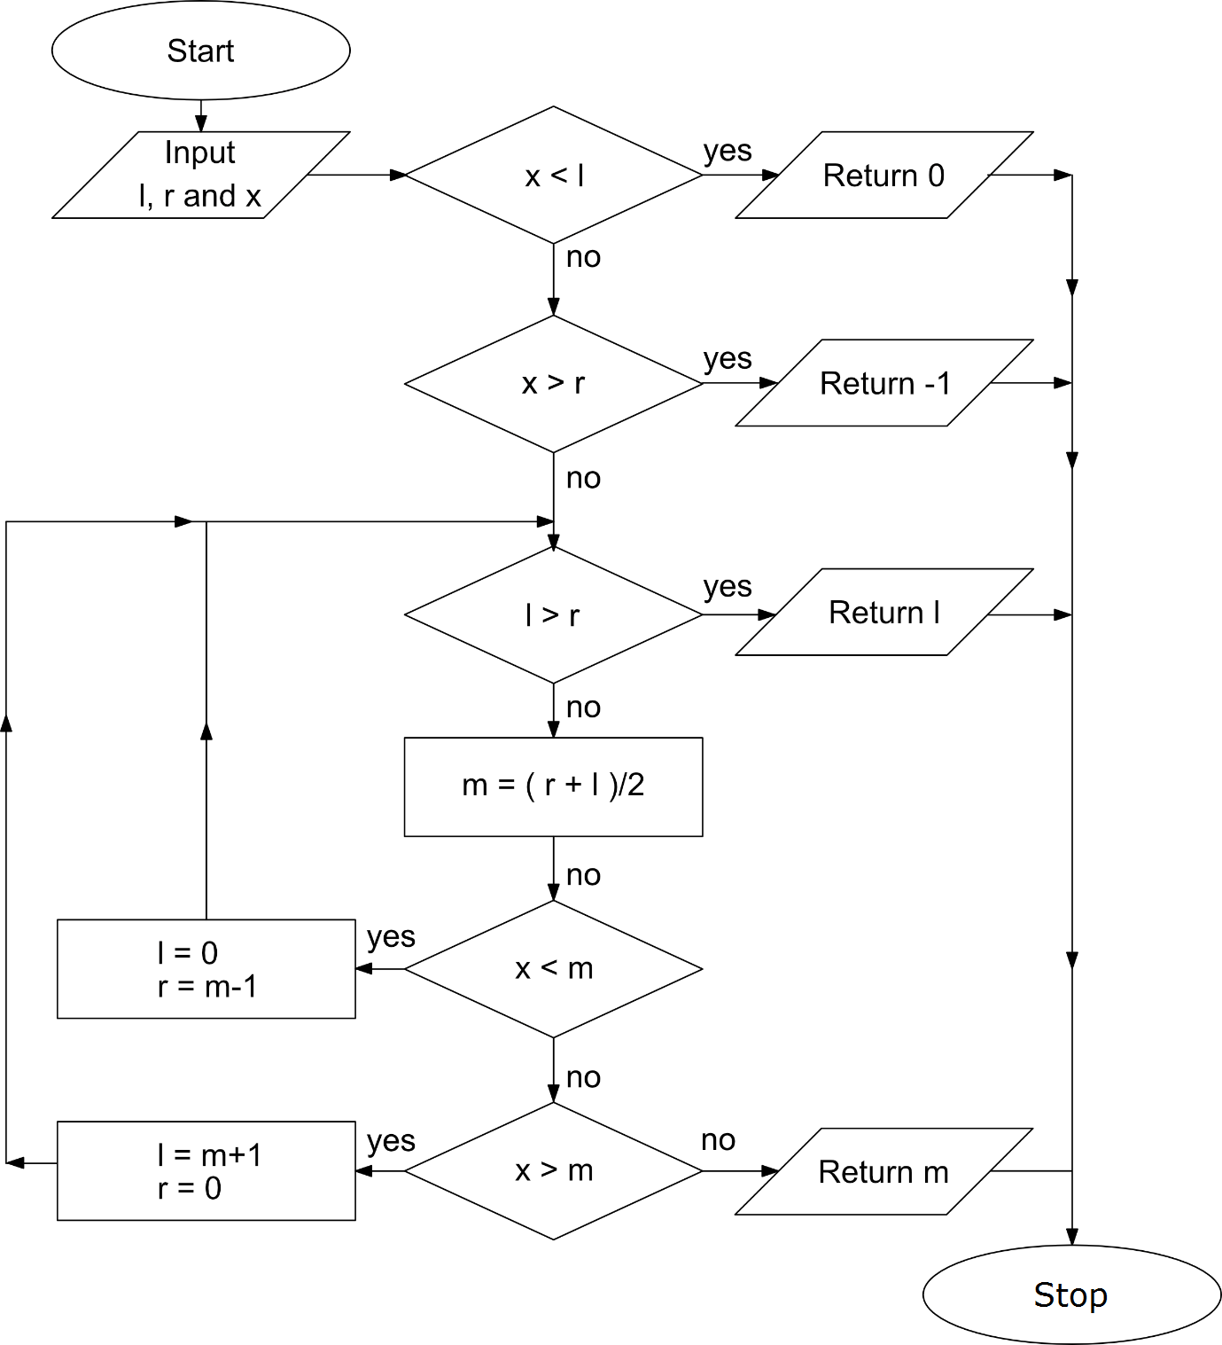

Figure 2: Flowchart for binary search to return index for the new products

In the following flowchart, ‘x’ denotes the key, ‘l’ indicates the left index, ‘r’ indicates the rightmost index and ‘m’ is simply the middle index.

(The code for this binary sort is also further discussed in the appendix.)

# Method Description

A Java method contains statements that are put together to perform an operation in java code (Jenkov, 2015). It helps to make the code modular and reuse the code. The java program to manage the information regarding laptops were created with two separate java class. The method described for the main java class that implements the GUI and the “Laptop” class is given below with the method, arguments, summary and return datatype specified.

Table 1: Method Summary for FindYourLaptop class

|  |  |
| --- | --- |
| Method Summary | |
| Constructor | FindYourLaptop()  The constructor of the FindYourLaptop class. |
| void, main  Static | main(String args[])  The main method for FindYourLaptop class. |
| Void | initComponents()  The autogenerated method that manages The GUI. |
| Boolean | not duplicate(String productModel, int index)  Method to check for duplicate values from a certain index in the table and return a Boolean value to indicate duplicate entry. |
| void | displayAll()  The method that will add 12 laptop items to the system. |
| void | addProduct(Laptop product)  The method that will take a laptop object and store it in tables and ArrayList(s).  This method will also implement the insertion mechanism. |
| void | void productIterator() (only necessary for debugging)  The method will iterate through various ArrayList and print them in the console. |
| int | binarySearcher(ArrayList<Integer> priceArray, int leftIndex, int rightIndex, int x)  The method that uses a binary search algorithm to find a specific item from a sorted array and return the index. |
| int | **binarySearchToSort(int x, ArrayList<Integer> sortedIntArraylist)**  The method that uses a binary search algorithm to return the index in which the new data should be added. |
| void | clearInput()  Method That will clear all the user inputs |
| void | addActionPerformed(java.awt.event.ActionEvent e)  The method that will take user input for a product and store it when “Add” button is pressed. |
| void | clearActionPerformed(java.awt.event.ActionEvent evt)  Method to clear the form after pressing the “Clear” Button. |
| void | jbtnPriceActionPerformed(java.awt.event.ActionEvent evt)  The method that will take user input for a product with specific price and search the product using a binary search when the “Search” Button is pressed. |
| void | jbtnScreenActionPerformed(java.awt.event.ActionEvent evt)  The method that will take user input for a product with specific screen-size and search the product when the “Search” Button is pressed. |
| void | jmiDocActionPerformed(java.awt.event.ActionEvent evt)  Opens documentation file when the “Open Documentation” menu item is pressed |
| void | void jmiExitActionPerformed(java.awt.event.ActionEvent evt)  Closes the program when the “Exit” menu item is pressed |
| void | jmiClearActionPerformed(java.awt.event.ActionEvent evt)  Clears all the user input in the program when the “Clear” menu item is pressed |
| void | jmiALCActionPerformed(java.awt.event.ActionEvent evt)  Prints all the array list content in the console when “Array List Content” item is pressed. (only for debugging) |
| void | jmiExitKeyPressed(java.awt.event.KeyEvent evt)  To link the “Ctrl+x” button to exit the program. |
| void | jmiClearKeyPressed(java.awt.event.KeyEvent evt)  To link the “Ctrl+c” button to clear the user inputs. |

Table 2: Method Summary for laptop object

|  |  |
| --- | --- |
| Method Summary | |
| Constructor | Laptop(int sN, String manufacturer, String modelNumber, String processor,  String screenSize, String ram, int storage, int price)  The constructor of the Laptop object. |
| String[ ]  (Array) | **getLaptop()**  The method that returns all the laptop detail in form of an array of string. |
| Void | **displayModel()**  Displays the laptop information about model number and price in the console |
| int | **getSN()**  Accessor method to get the Serial No of the product. |
| String | getManufacturer()  Accessor method to get the Manufacturer of the product. |
| String | getModelNumber()  Accessor method to get the Model Number of the product. |
| String | getProcessor()  Accessor method to get the Processor info of the product. |
| String | getScreenSize()  Accessor method to get the screen size of the product. |
| String | getRam()  Accessor method to get the memory-size of the product. |
| int | **getStorage()**  Accessor method to get the storage Size of the product. |
| int | **getPrice()**  Accessor method to get the price of the product. |

# Testing

## Running in NetBeans:

Table 3: (Test 1) Running in NetBeans

|  |  |
| --- | --- |
| Objective | Checking whether the program can be imported and be run from NetBeans or not in another computer. |
| Action | Opening NetBeans and importing the project.  Running the FindYourLaptop class. |
| Expected  Result | The file gets compiled and GUI opens. |
| Actual  Result | File compiled and GUI is opened after giving the path where the file is located. |
| Conclusion | Test Successful. |

(Note: This project will have different themes on different OS The first testing done on the Windows While the rest is done on Mac OS X)

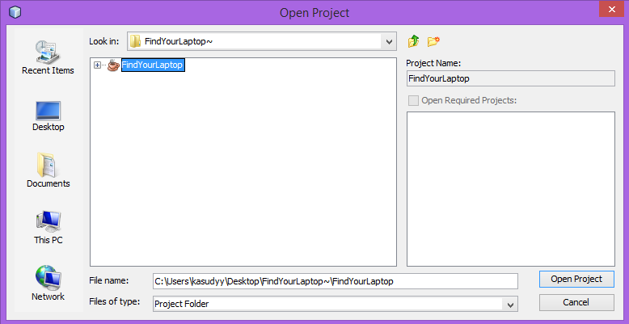

Figure 3: (Test 1): Importing Project File

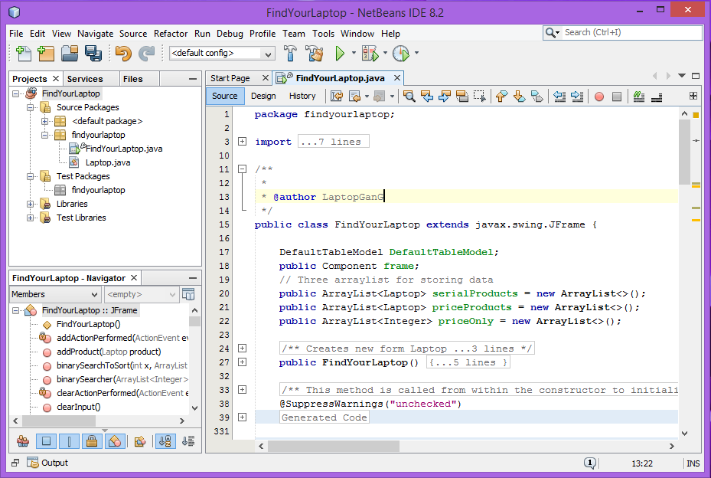

Figure 4: (Test 1): Running the GUI class

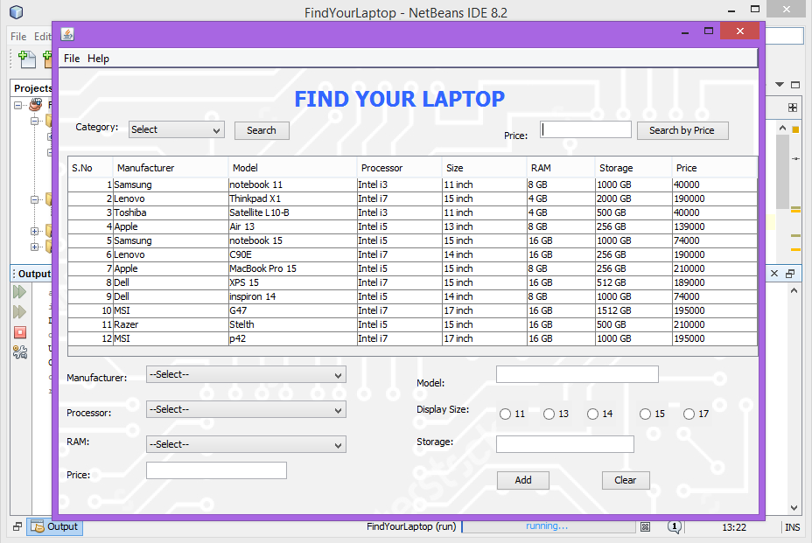

Figure 5: (Test 1): Find Your Laptop Running

## Adding an Item:

Table 4: (Test 2) Adding an item

|  |  |
| --- | --- |
| Objective | Checking whether the program adds new items or not.  Also if all the information gets added or not. |
| Action | Adding new products to a unique Model number  Checking the added data in the table |
| Expected  Result | The product will get added,  Serial Number will be generated,  The product is displayed on the table. |
| Actual  Result | The product was added,  New Serial Number for the product was generated,  The product was displayed at the table. |
| Conclusion | Test Successful. |

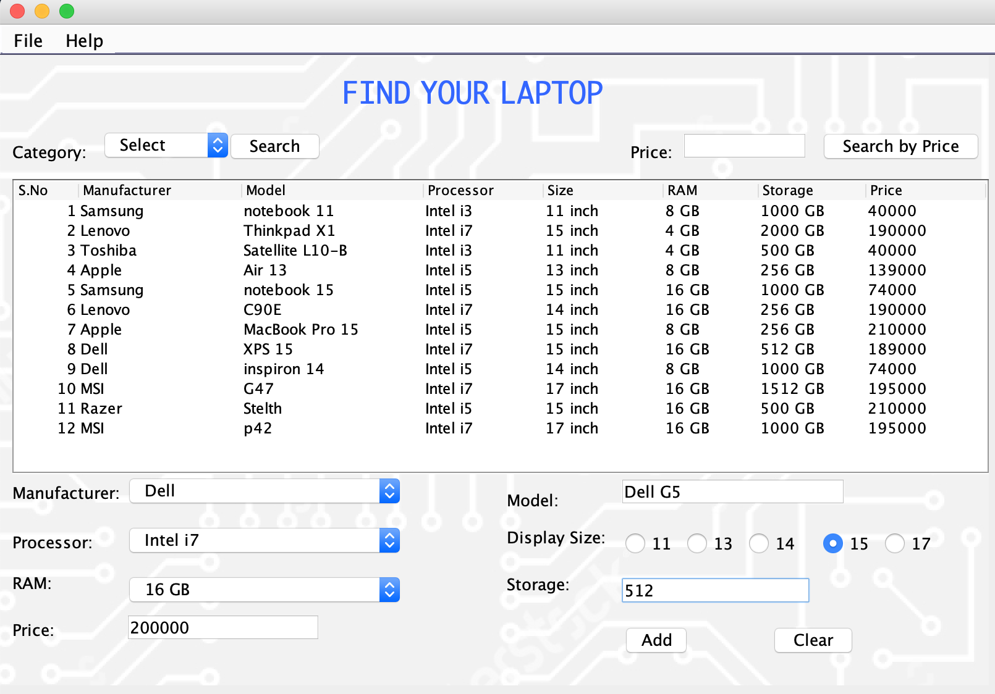

Figure 6: (Test 2): Entering data

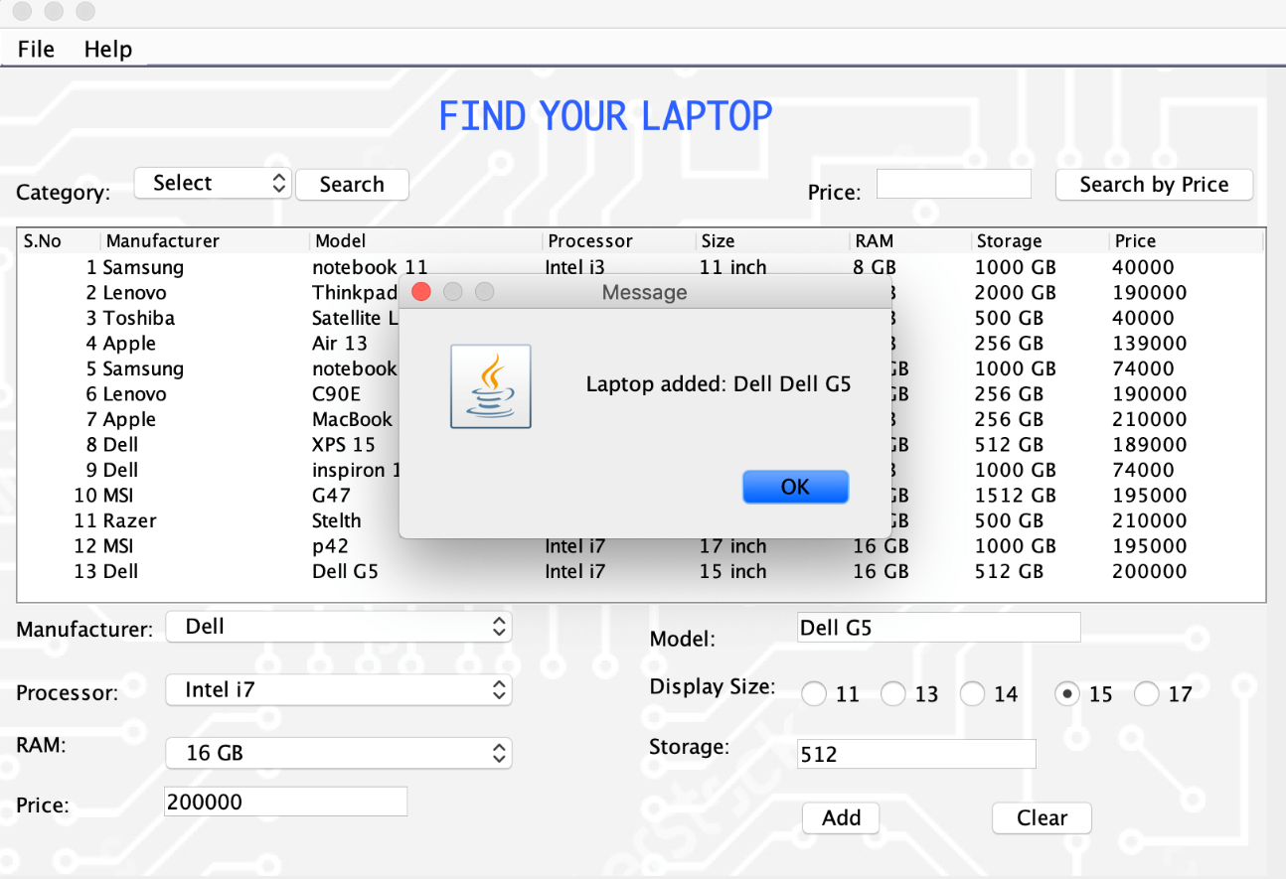

Figure 7: (Test 2): Message pops up after adding

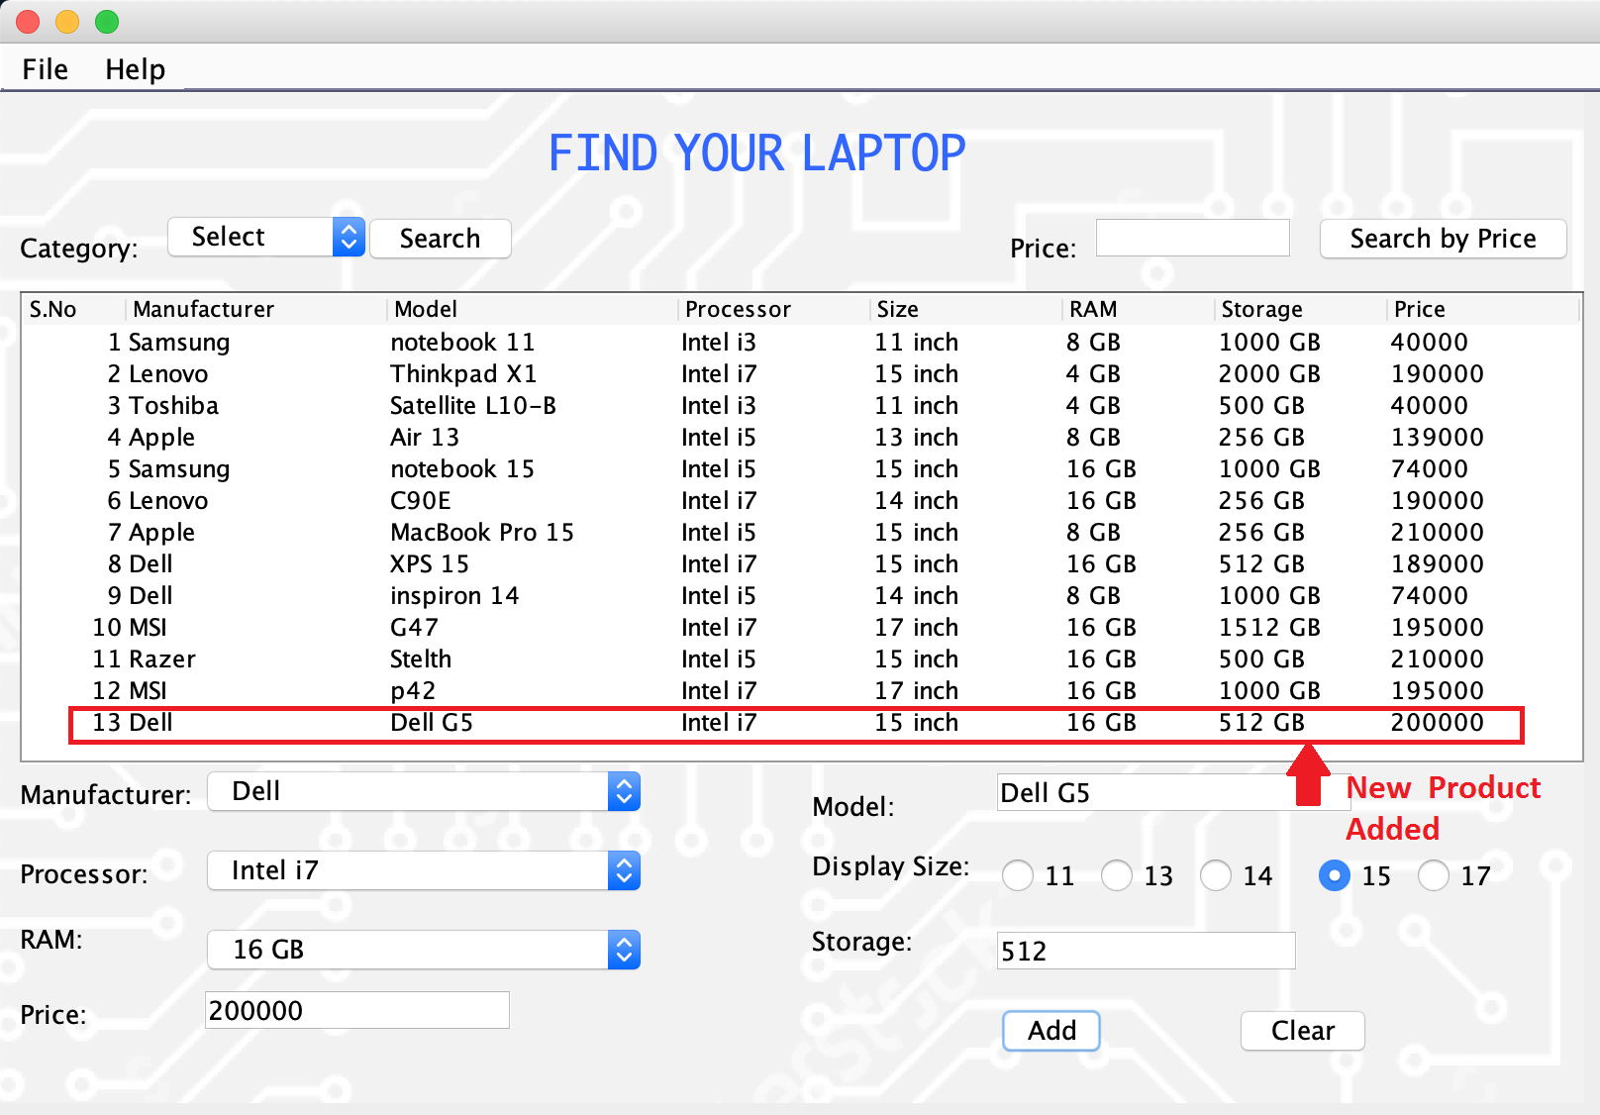

Figure 8: (Test 2): Item added in the table

## Searching by Category (Screen-size):

Table 5: (Test 3) Searching by category

|  |  |
| --- | --- |
| Objective | Checking whether the program can find products according to the specific screen-size category. |
| Action | Searching for laptops with a 15-inch screen.  Searching laptop with a 17-inch screen. |
| Expected  Result | The program will show all the laptops with the selected screen-size when the search button will be pressed. |
| Actual  Result | The program showed all the 15-inch laptops and 17-inch laptops when searching by category |
| Conclusion | Test Successful. |

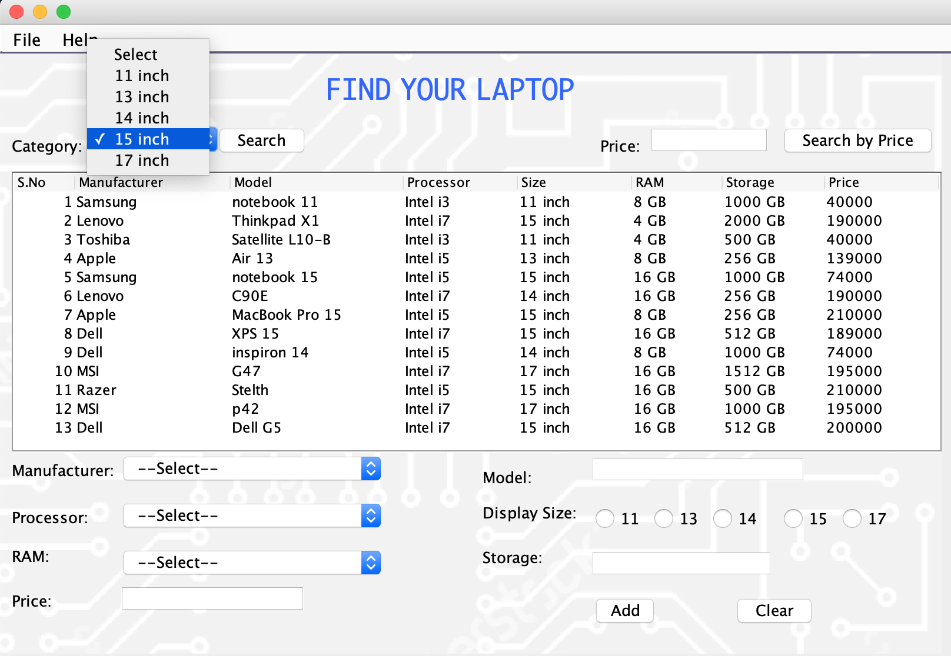

Figure 9: (Test 3): Searching by category, selecting 15 inch

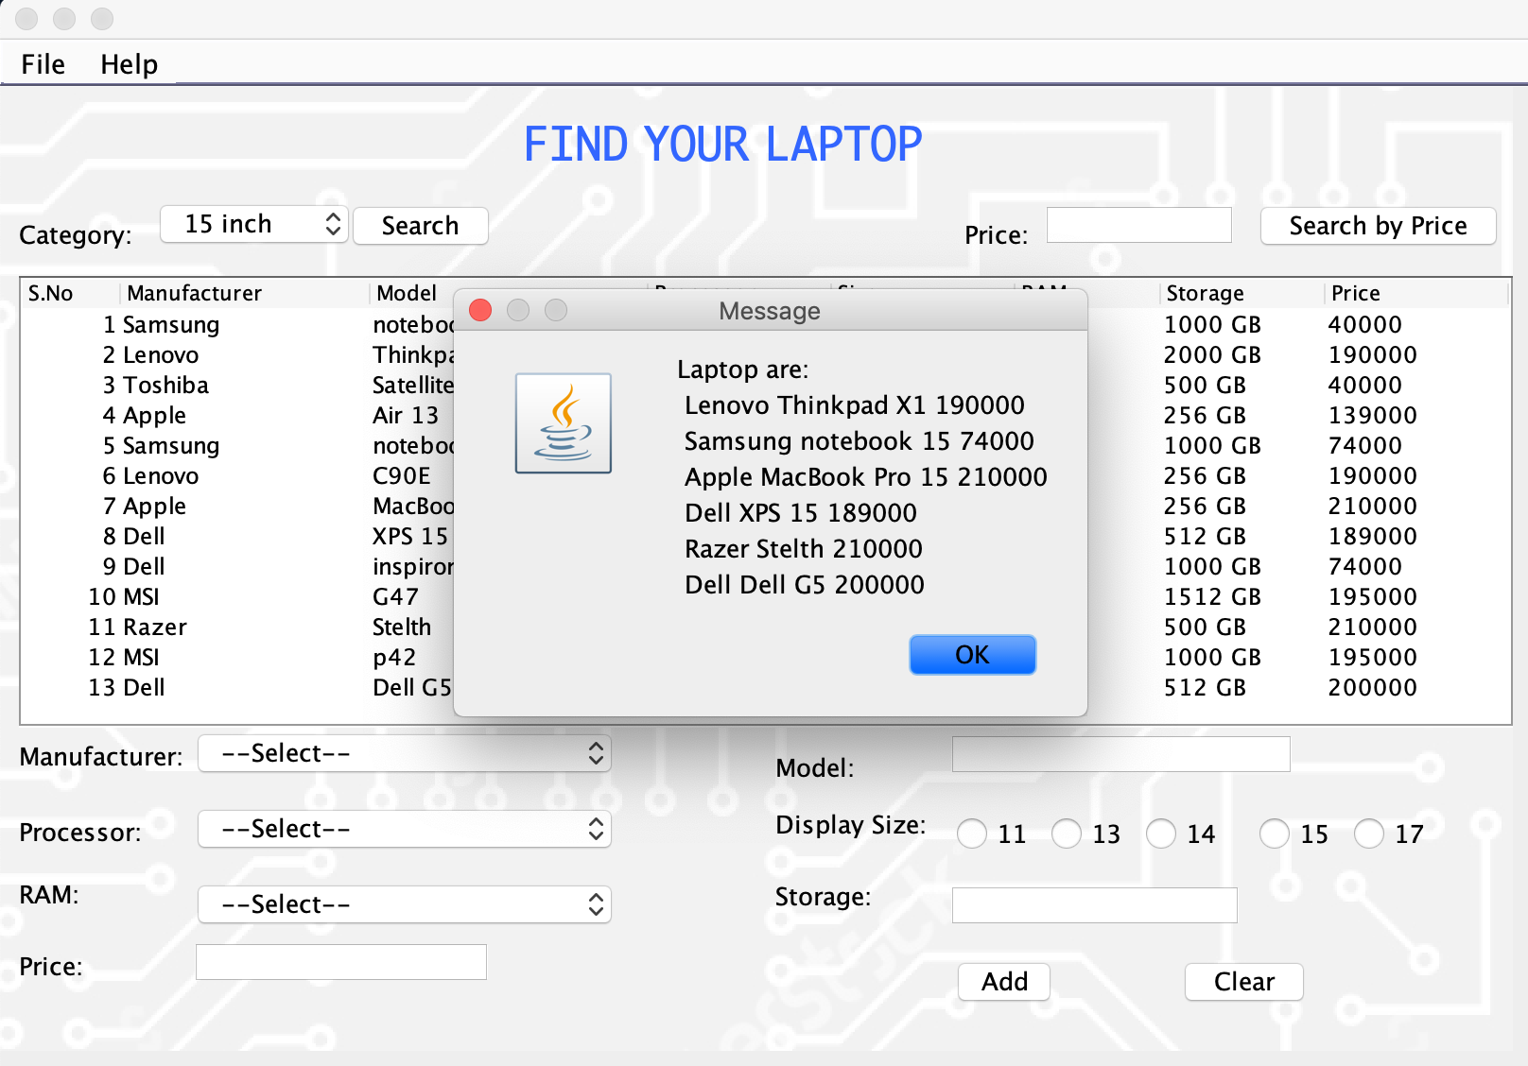

Figure 10: (Test 3): Displaying all 15-inch laptops

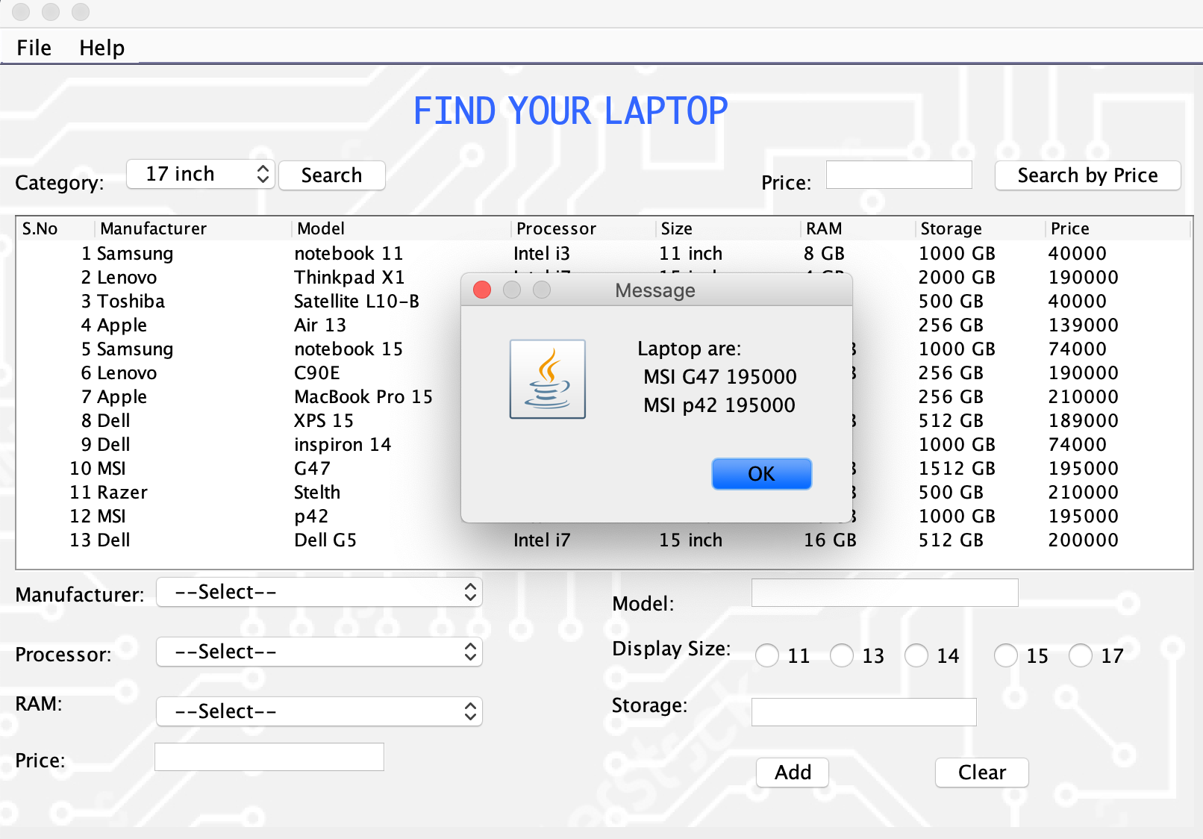

Figure 11: (Test 3): Similarly, displaying all 17-inch laptops

## Searching by Price:

Table 6: (Test 4) Searching by price

|  |  |
| --- | --- |
| Objective | Checking whether the program can find products according to price. |
| Action | Searching for a laptop with a price: 210000 (only one device has this price  Searching for a laptop with a price: 40000 (multiple devices have this price) |
| Expected  Result | The program will show one item when the search button is pressed if the system contains a product with that price.  Else the program will notify the user that the product with that specific price doesn’t exist in the system. |
| Actual  Result | The program showed a laptop when there was only one item,  Program notified the user about the absence of a laptop when the price didn’t match to any entry,  The program showed the first laptop when there were multiple numbers of products with the same price point |
| Conclusion | Test Successful. |

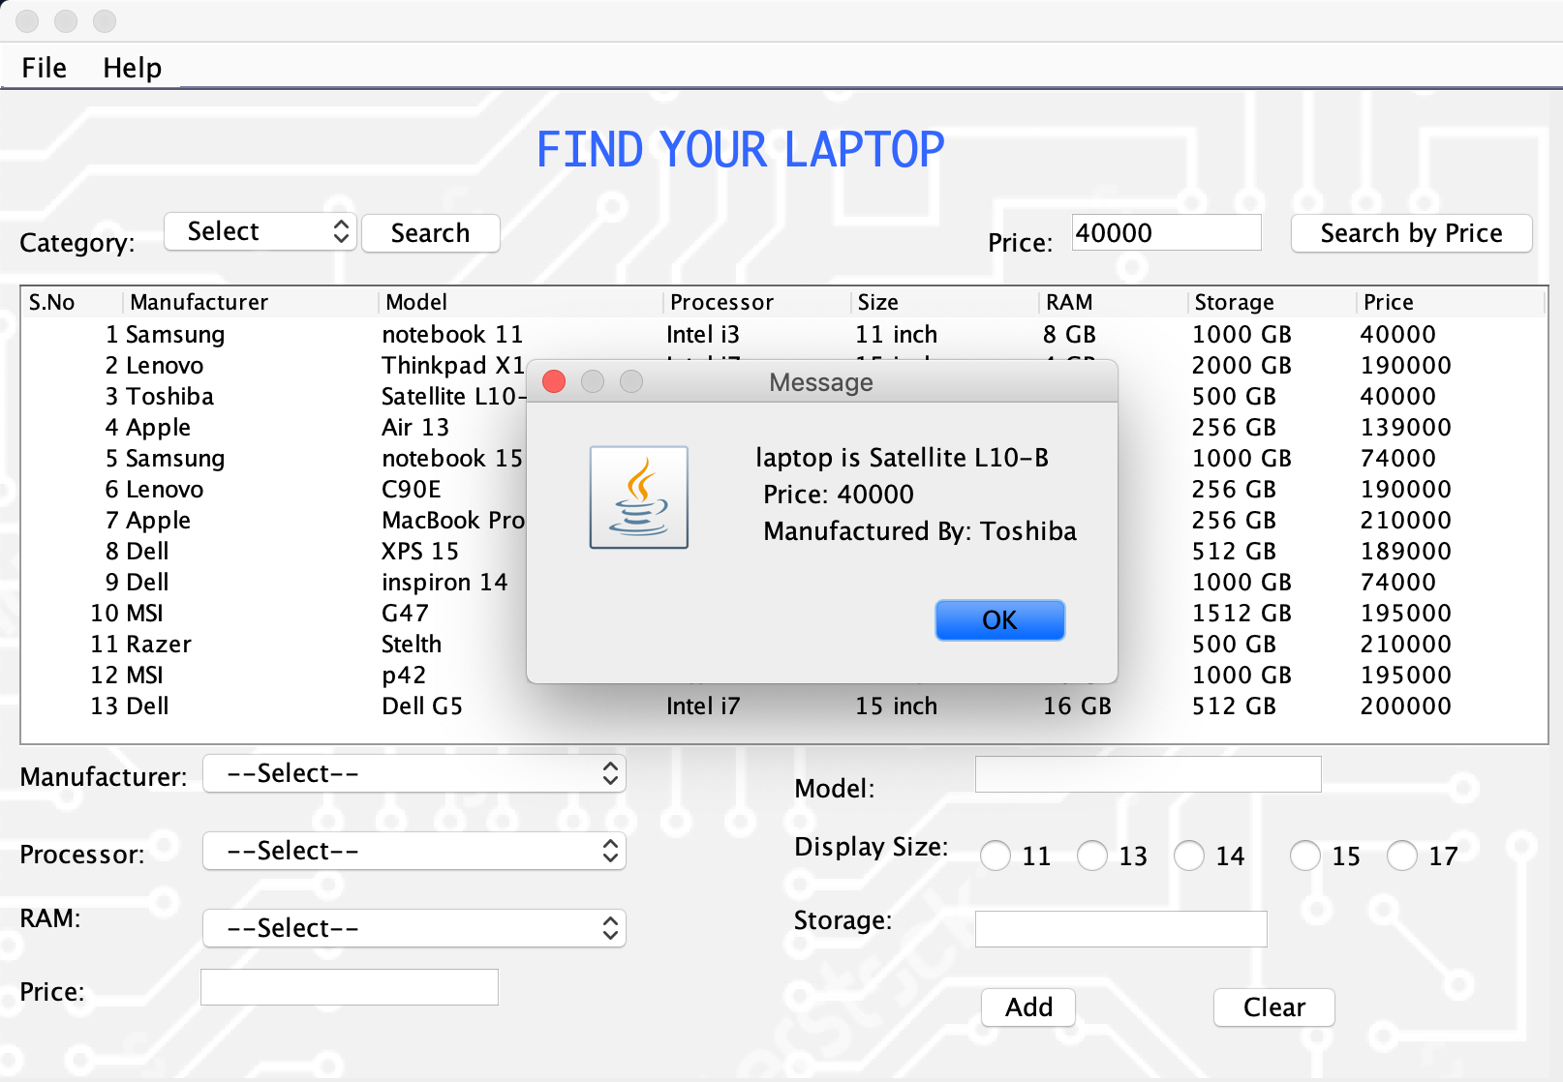

Figure 12: (Test 4): Searching for a laptop by price 40000 (With multiple entries)

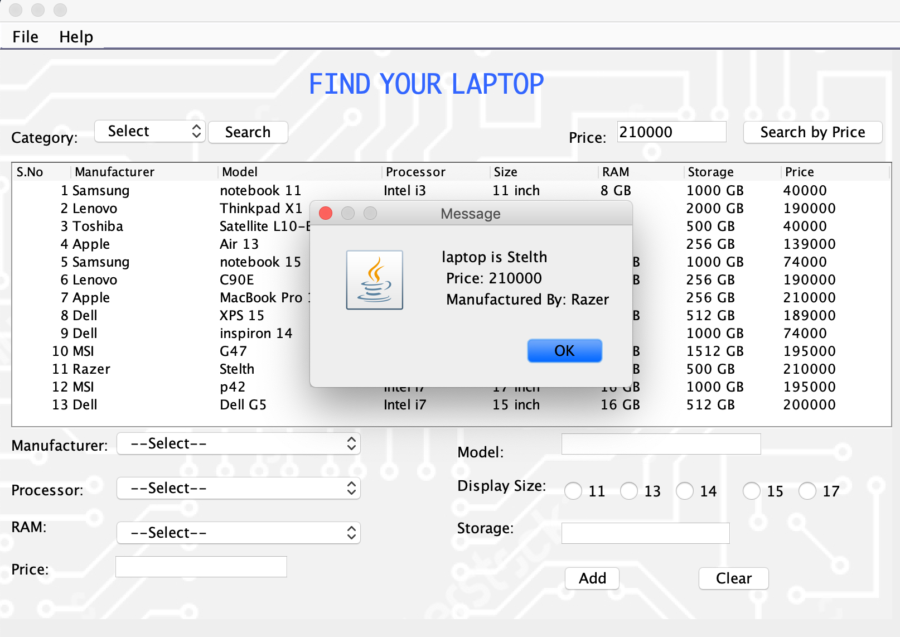

Figure 13: (Test 4): Searching for a laptop by price 210000 (With Single entry)

## Exception Handling:

Table 7: (Test 5) Exception Handling

|  |  |
| --- | --- |
| Objective | Checking whether the program can handle various exceptions or not |
| Action | Inputting String where integer needs to be taken,  Inputting number greater than the highest product price at the search by price. |
| Expected  Result | The program will display error in a pop-up box to notify about the errors that have occurred due to improper use of the system. |
| Actual  Result | The program specified exact reason for the error for the user suggesting they alter their actions for the right result. |
| Conclusion | Test Successful. |

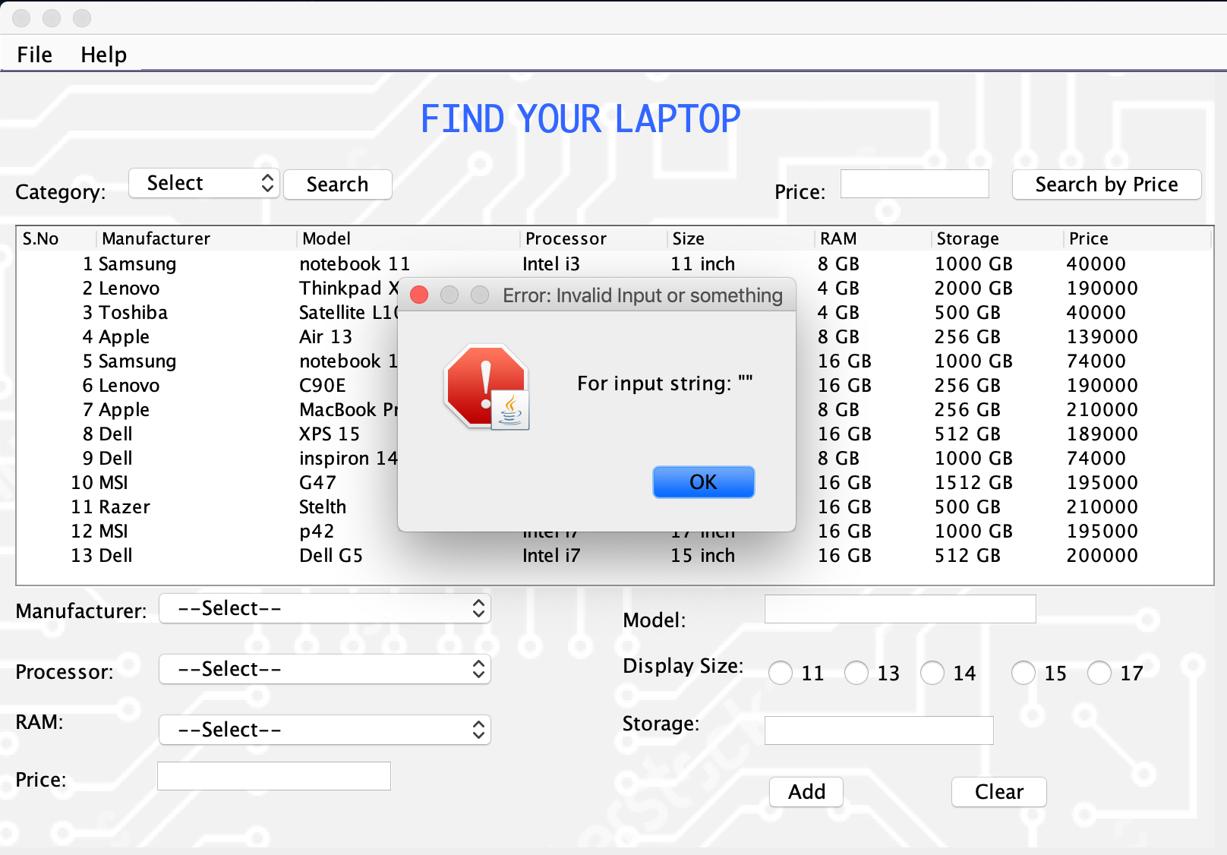

Figure 14: (Test 5): Error due to empty fields which require integer input

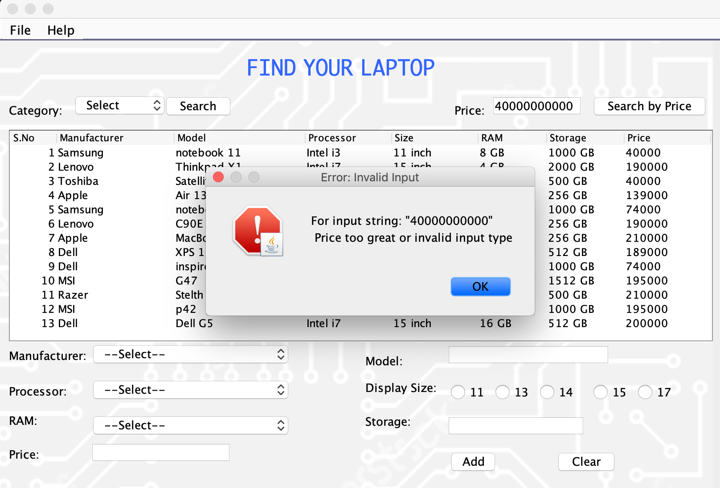

Figure 15: (Test 5): Error due to higher than the highest price in a search by price

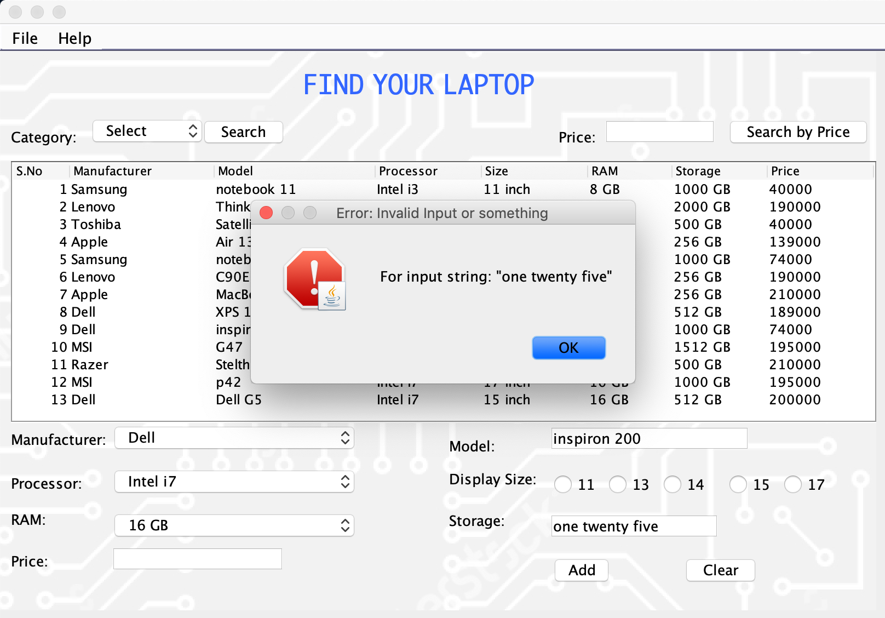

Figure 16: (Test 5): Error due to string input in place of integer

## User Input Error Handling

Table 8: (Test 6) User Input error handling

|  |  |
| --- | --- |
| Objective | Checking whether the program can detect empty fields or repeated model number in the program. |
| Action | Add button was pressed with all the fields empty,  Add button was pressed with no screen size selected(radio-button),  Add button was pressed with no price (text-field),  Add button was pressed with no processor (combo-box),  Add button was pressed with duplicate model-no(duplication check) |
| Expected  Result | The product doesn’t get added and the user gets notified about the errors in an understandable context in a pop-up box. |
| Actual  Result | The product wasn’t added and the user was notified about the incomplete or duplicate entries. |
| Conclusion | Test Successful. |



Figure 17: (Test 6): Error due to Empty Fields

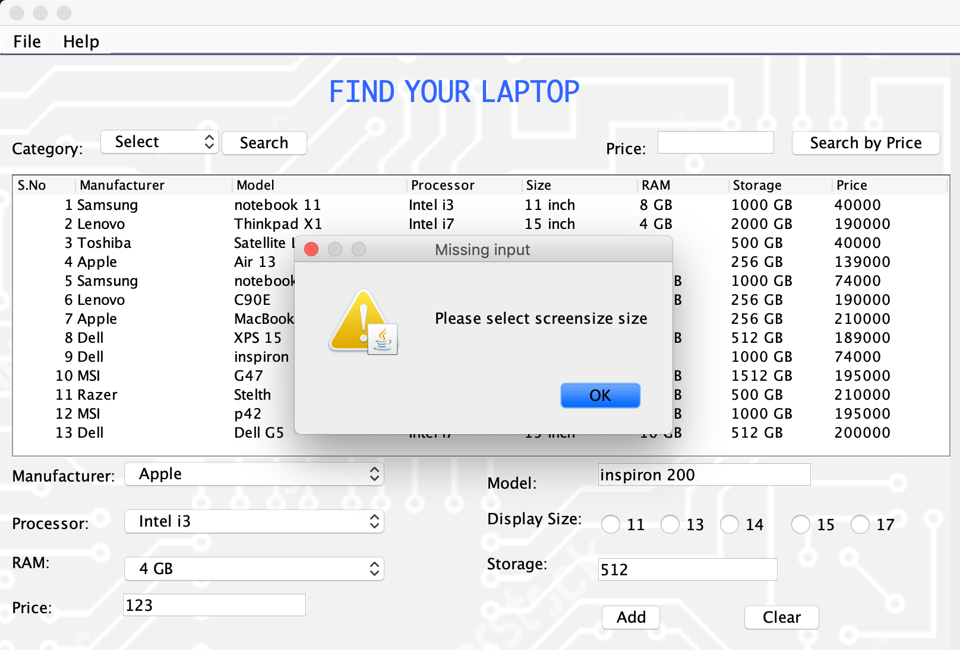

Figure 18: (Test 6): Error due to missing screen-size details

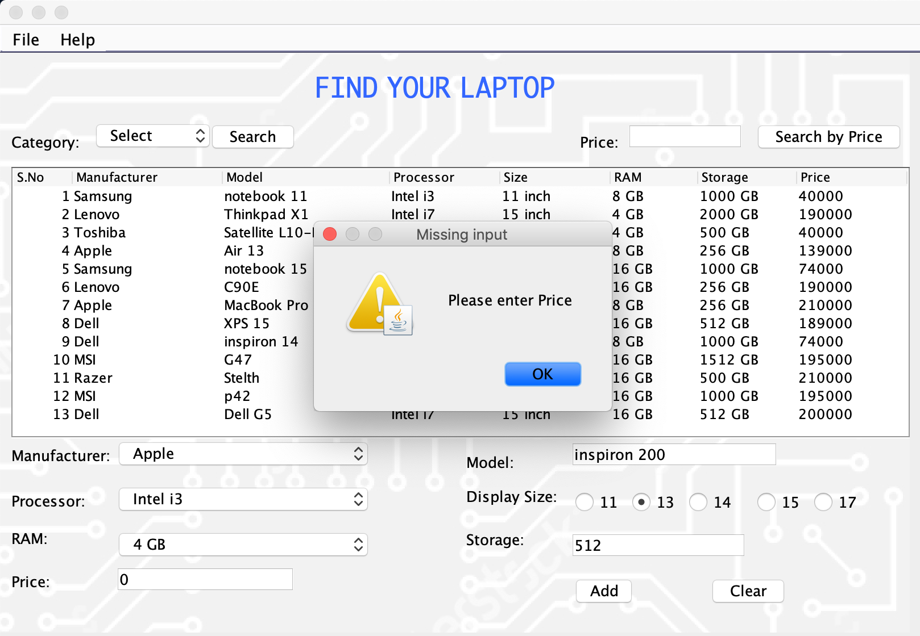

Figure 19: (Test 6): Error due to missing price

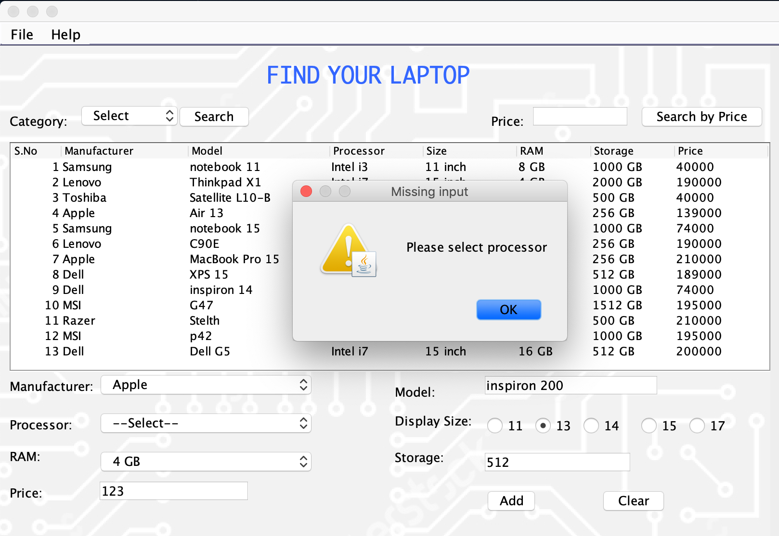

Figure 20: (Test 6): Error due to missing processor details

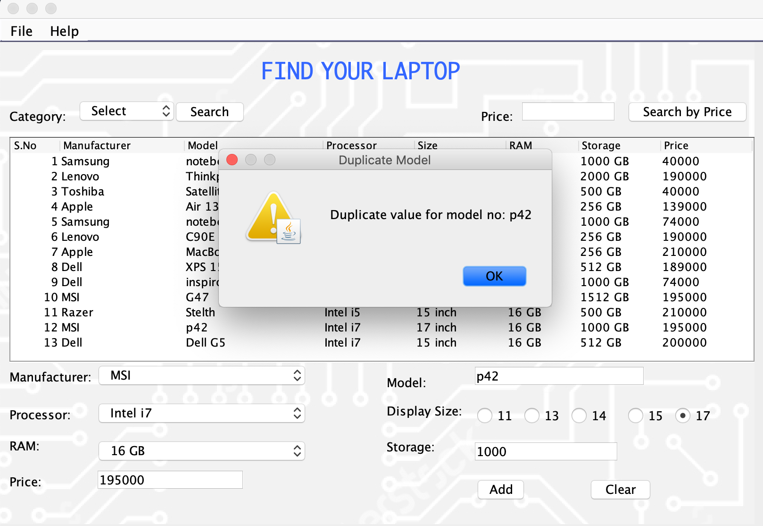

Figure 21: (Test 6): Error due to duplicate value for a model number

## Checking the functionality of other features:

Table 9: (Test 7) Other Features checking

|  |  |
| --- | --- |
| Objective | Checking whether the menu items, clear button and sorting the table works |
| Action | Clearing the input via the “clear” button,  Clearing the input via the “clear” menu item in the file,  Clicking the column indicator to sort the product,  Exiting the program.  Trying to open the documentation from the “view documentation” option on the menu item within help. |
| Expected  Result | Input fields will be cleared by the button and the menu item,  The items will be sorted according to the column,  The program will exit if the exit menu item is pressed,  Documentation file gets opened. |
| Actual  Result | The input fields were cleared,  Items were sorted,  Documentation file was opened,  The program was terminated. |
| Conclusion | Test Successful. |

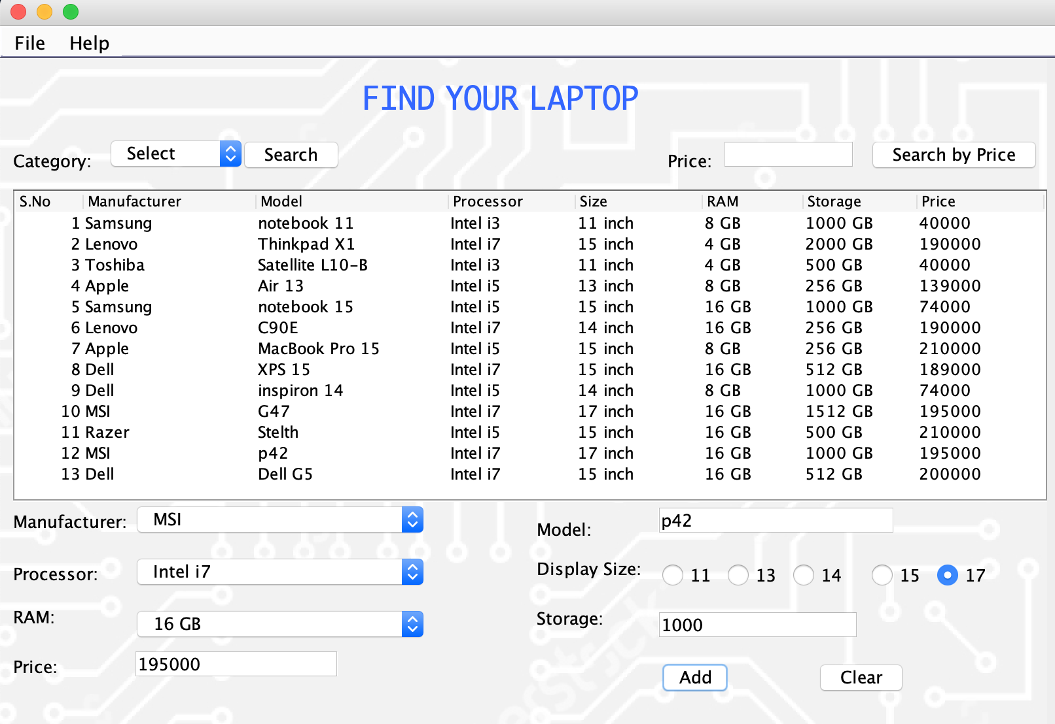

Figure 22: (Test 7): Unwanted user input to be cleared

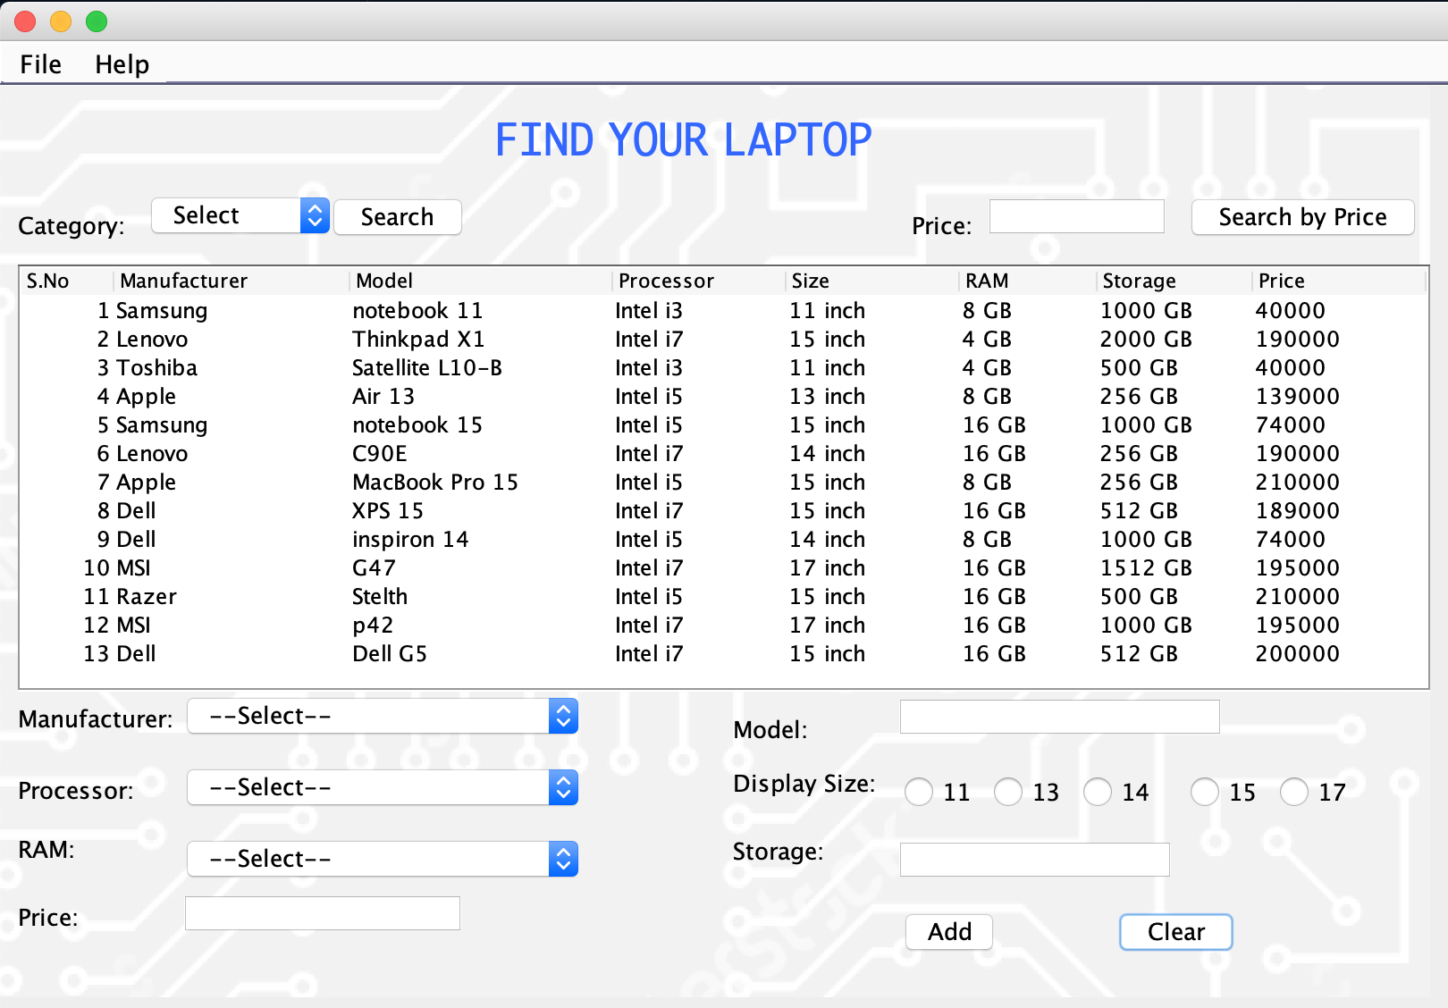

Figure 23: (Test 7): Pressing Clear Button

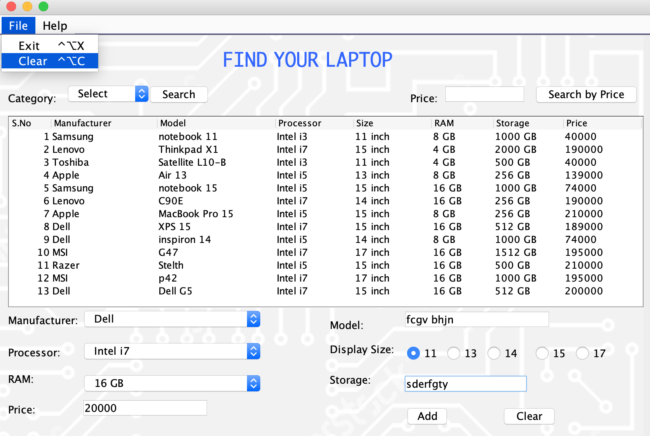

Figure 24: (Test 7): Clearing using Menu item Clear option

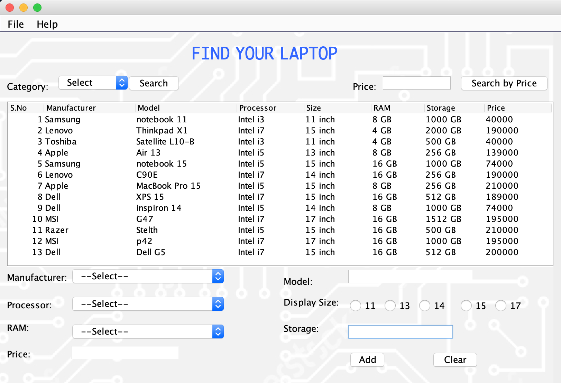

Figure 25: (Test 7): Cleared User input due to the Clear action

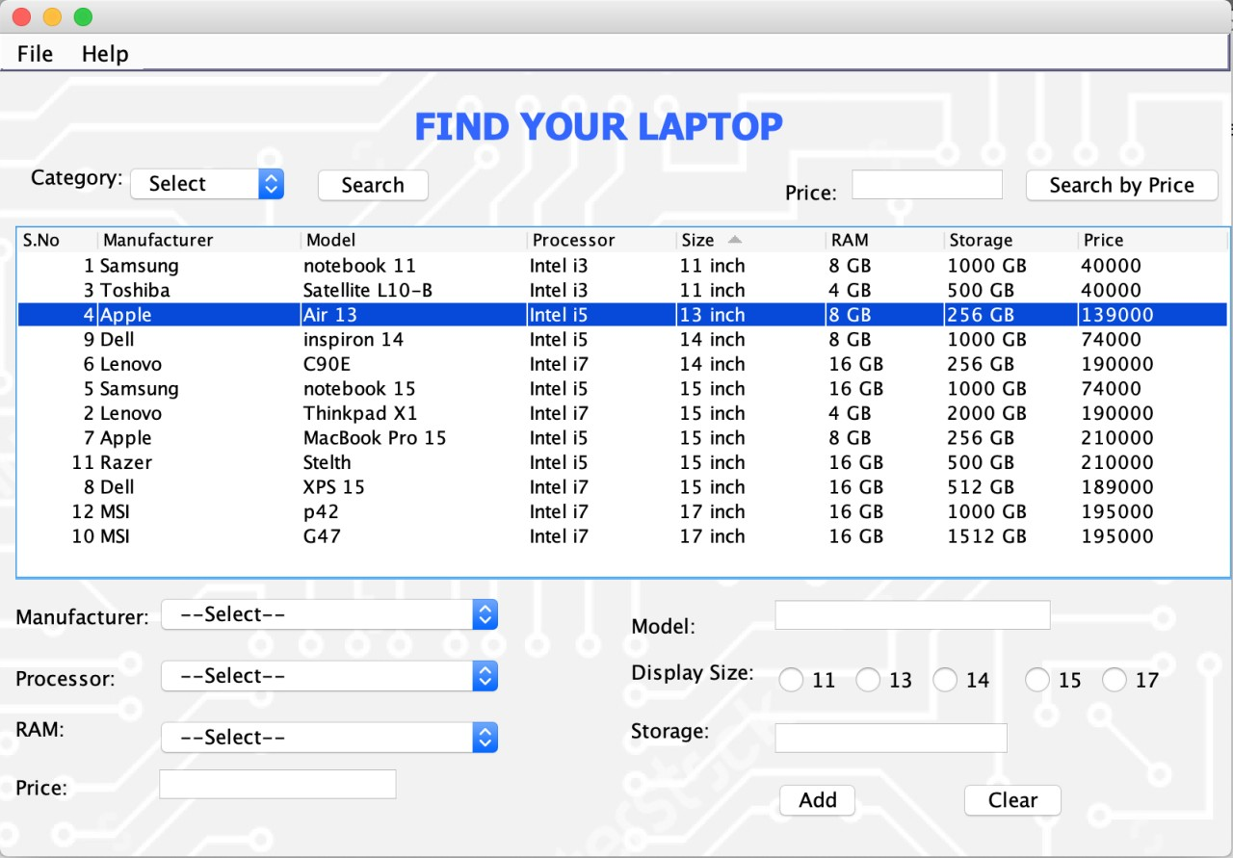

Figure 26: Sorting the laptops according to the screen-size

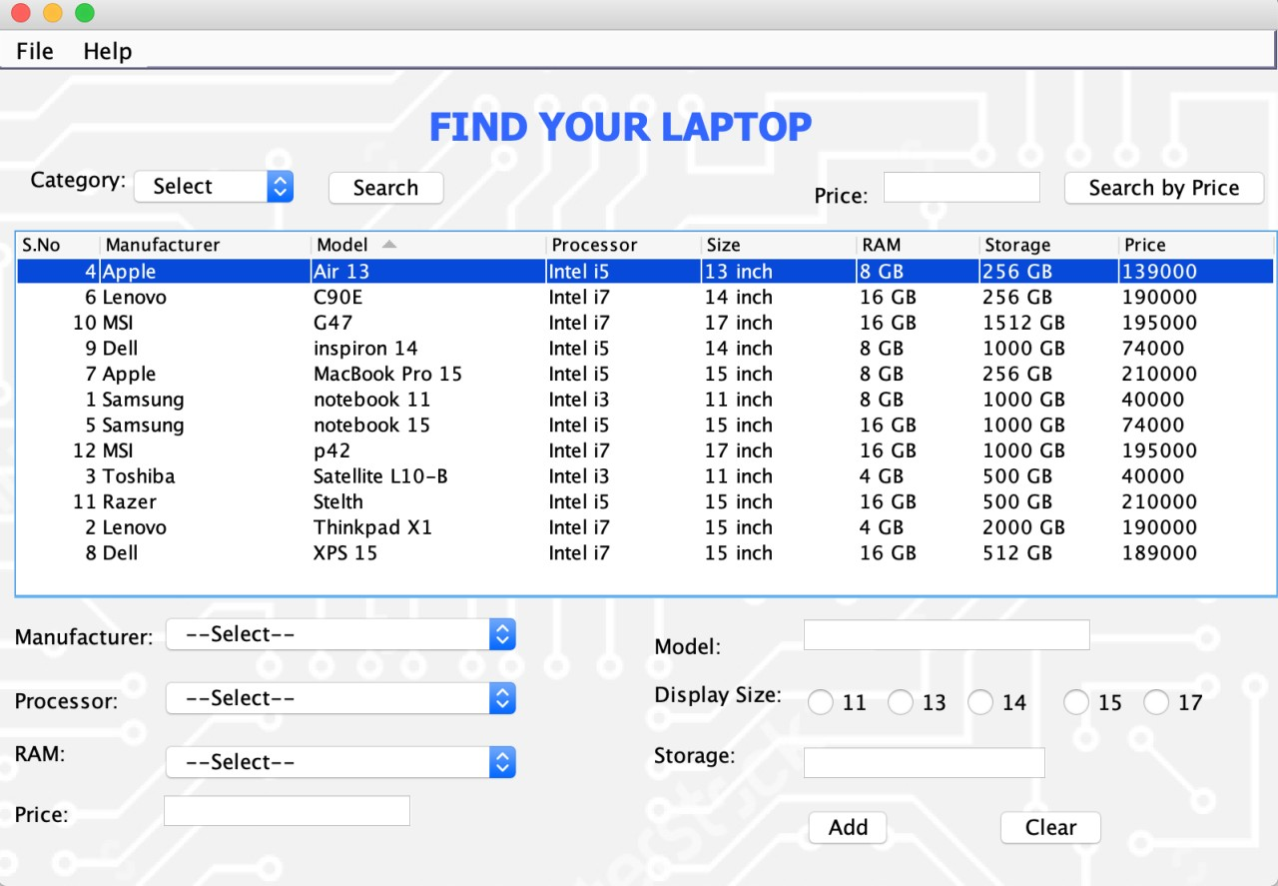

Figure 27: Sorting according to the manufacturer by clicking on the manufacturer column header

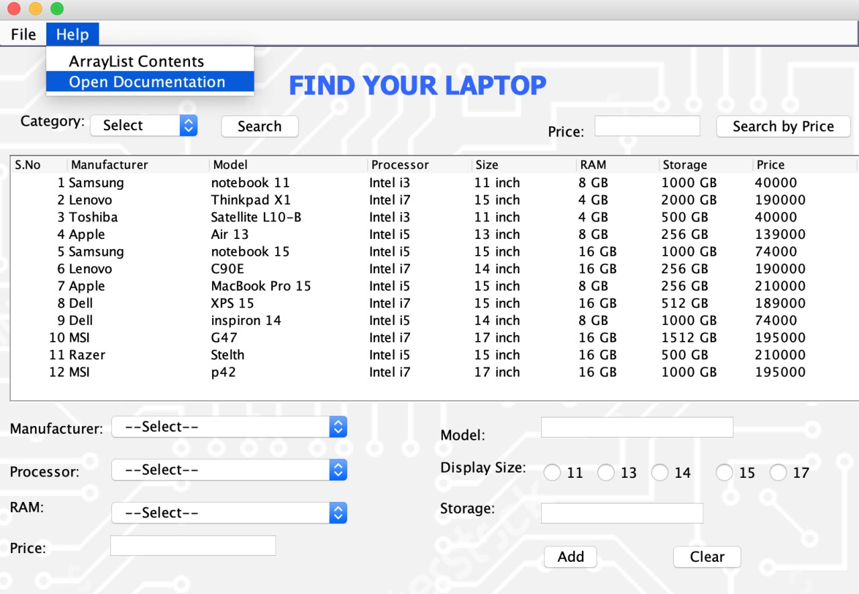

Figure 28: Selecting open documentation option

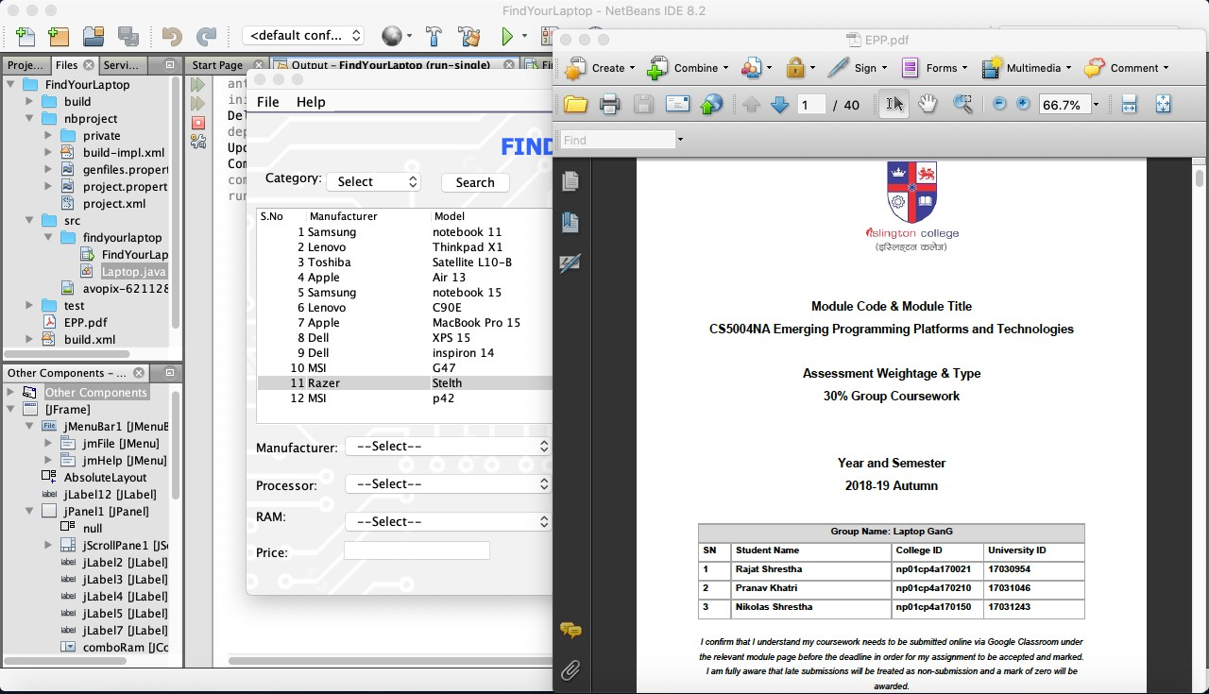

Figure 29: The PDF document opens

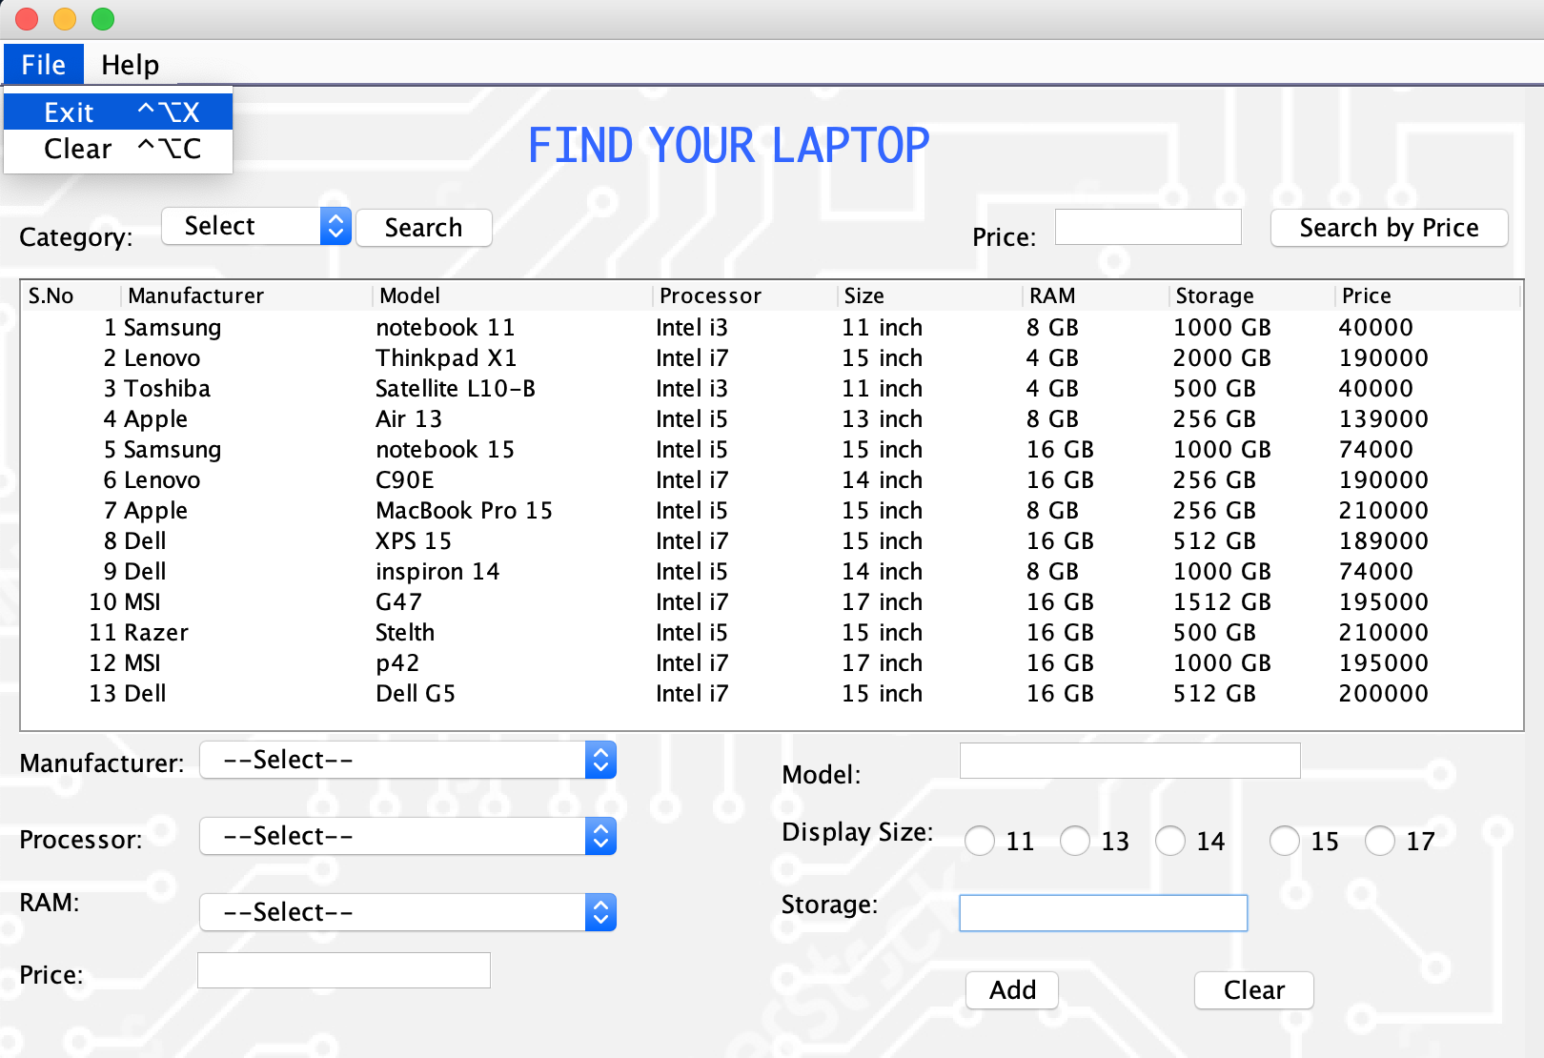

Figure 30: (Test 7): Checking the close option

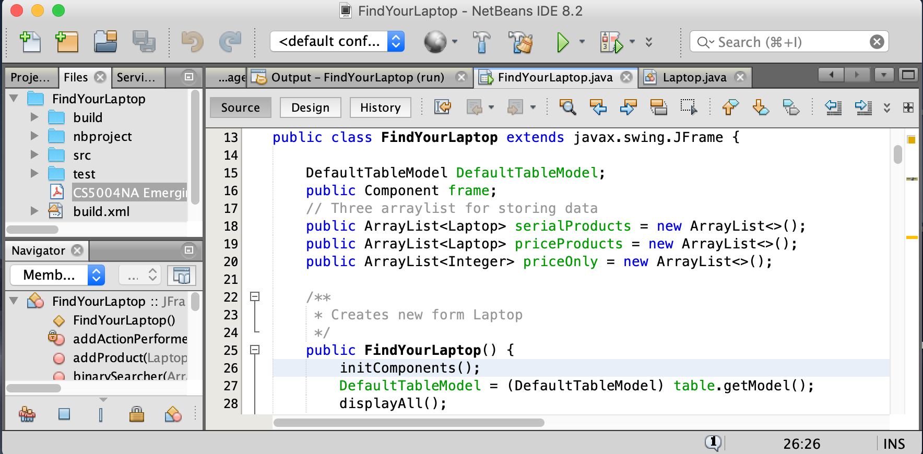

Figure 31: Program terminated due to close action

# Conclusion

While developing any kind of information systems, data must be created, stored, appended/modified or deleted. So to make this task easier data structures must be implemented. And to process any piece of information, to sort or to search various algorithms are required to be implemented in the program. The sorting algorithm used in this program is a variant of Selection sort, in this modified selection sort will automatically sort the user input in the ArrayList according to their price. Even though linear sort is quite inefficient, this version of selection sort was used because it is easier to understand and works well on a small amount of data. The sorting was required to sort the data according to their prices because the searching algorithm used in this program is a binary search which can work only on sorted data. Binary search is an efficient searching algorithm as it can be expressed in logarithmic functions. This means that this searching algorithm will work really well when there is a huge amount of data from which an item needs to be searched. A separate java class was also created, which handled all of the processes and methods required to compare and retrieve information about any laptop object in the main java class which provided a platform for the GUI.

The user interface is also a key factor that needs to be analyzed and work upon as it greatly influences the actions that a user can do in an information system. So to enhance the user experience the GUI is made as simple and attractive as possible so that it will affect the user positively while using this program. While testing, the software was required to perform a certain task which it has done effortlessly. The GUI can be easily opened by importing the project and adding new data is relatively easy. The program will sort the data as it is entered according to its price so when the user searches any product the product can directly use a binary search algorithm to search for that item. The program also features many small other features like clearing all the input fields, exiting the program and viewing the user guide for the program. The help button also contains a function that will list out all the items stored in the ArrayList which can be observed in the console.

# References

Hopping, C., 2018. *What is a graphical user interface?.* [Online]   
Available at: https://www.itpro.co.uk/operating-systems/30248/what-is-a-graphical-user-interface  
[Accessed 18 1 2019].

Jacobson, N. & Thornton, A., 2004. It is Time to Emphasize ArrayLists over Arrays. *inroads – The SIGCSE Bulletin ,* 36(4), pp. 88-92.

Jenkov, J., 2015. *Java Methods.* [Online]   
Available at: http://tutorials.jenkov.com/java/methods.html  
[Accessed 17 Jan 2018].

Knoernschild, K., 2002. *Java Design: Objects, UML, and Process.* 1st ed. Boston: Addison-Wesley Professional.

Mahmoud, H. M., 2011. *Sorting: A Distribution Theory.* 1st ed. New Jersey: John Wiley & Sons.

Oracle , 2019. *Package javax.swing.* [Online]   
Available at: https://docs.oracle.com/javase/7/docs/api/javax/swing/package-summary.html  
[Accessed 18 1 2019].

Rouse, M., 2014. *What is object-oriented programming (OOP)? - Definition from WhatIs.com.* [Online]   
Available at: http://searchmicroservices.techtarget.com/definition/object-oriented-programming-OOP  
[Accessed 18 Jan 2018].

The Interaction Design Foundation, 2018. *User Experience (UX) Design.* [Online]   
Available at: https://www.interaction-design.org/literature/topics/ux-design  
[Accessed 18 1 2019].

Weisstein, E. W., 2018. *Binary Search.* [Online]   
Available at: http://mathworld.wolfram.com/BinarySearch.html  
[Accessed 20 1 2019].

Williams Jr., L. F., 1976. *A modification to the half-interval search (binary search) method.* Bringham, Proceedings of the 14th annual Southeast regional conference.

# Appendix

## The limitations of the binary search algorithm:

1. When there are two items which fulfill the description of the search term the binary search will only return the first term it gets matched with.
2. When the search term doesn’t exist within the sorted data list, the binary search will not break the process but continues to search at the probable proximity of the search term until the algorithm realizes that the term doesn’t exist.
3. The binary search algorithm requires a sorted data to start searching. If the data is not sorted the binary search will not function at all.
4. While working on a small amount of data, the binary search will first have to sort the data then perform a binary search. This will take more time to sort and search than by using just linear searching algorithm to search the term.
5. The binary search algorithm used in this program will only return the index of the first item it comes across.
6. The other items with duplicate value are rejected or neglected according to this algorithm.

## Detailed method description for the binary search:

The method that implements the principle of the binary sort is mentioned below:

public int binarySearcher(ArrayList<Integer> priceArray, int leftIndex, int rightIndex, int x) {

if (rightIndex >= leftIndex) {

int middleIndex = ((rightIndex - leftIndex)/2) + leftIndex;

if (priceArray.get(middleIndex) == x){

System.out.println("found");

return middleIndex;

}

else if (priceArray.get(middleIndex) > x){

return binarySearcher(priceArray, leftIndex, middleIndex-1, x);

}

else{

return binarySearcher(priceArray, middleIndex+1, rightIndex, x);

}

}

return -1;

}

}

This method returns the index of the found term which will make it easier to call up the whole detail on the product. As the sorted price list is mapped with the sorted list containing the laptop objects. When the method is invoked when the search button is pressed the index is stored as an integer variable which is then used as an index to display the product details.

## Method for modified binary sort :

public int binarySearchToSort(int x, ArrayList<Integer> sortedIntArraylist) {

int leftIndex = 0;

int rightIndex = sortedIntArraylist.size() - 1;

// to make binary search more efficient by checking if:

// value is smaller than smallest

if(x < sortedIntArraylist.get(0)) {

return 0;

}

// if value is bigger than biggest

if(x > sortedIntArraylist.get(sortedIntArraylist.size()-1)){

return -1;

}

// searching by comparing with the middle index

// if the value exists withing the middle index it will return it

// else it will search within the sorted data untill the values are exhausted

while (leftIndex <= rightIndex) {

int middleIndex = (rightIndex + leftIndex) / 2;

int middleIndexValue = sortedIntArraylist.get(middleIndex);

if (x < middleIndexValue){

rightIndex = middleIndex - 1;

}

else if (x > middleIndexValue){

leftIndex = middleIndex + 1;

}

else {

return middleIndex;

// if the value exists it will return its index

}

}

// index of slightly bigger element

return leftIndex;

}

The index given out by this method is invoked by another method which adds the data to the table and sorts the data using insertion mechanism.

## Insertion technique

The first part of this code will simply add the new product data to the table and to a ArrayList in which products are stored serially. The second part however consists of the main insertion mechanism to sort the data by inserting it into the correct position. The position of the new product is first determined by the modified binary search algorithm designed to give the position within the sorted list of data. If the ArrayList is empty it will first add a data to the ArrayList. If the ArrayList isn’t empty it will take the new index given by the binary search for the new data and add the item to the specified position. If the value is greater than the greatest value within the ArrayList then the search algorithm will return “-1” which is identified by the program and the product is appended at the back of the ArrayList.

public void addProduct(Laptop product){

// method to add the product to table and arraylists

//addToTable(((Laptop)product).getLaptop()); // adds the product to table

DefaultTableModel.addRow(((Laptop)product).getLaptop());

serialProducts.add(product); // adds product to SN arraylist

// to add the product if the list is empty

if(priceOnly.isEmpty()){

priceProducts.add(product);

priceOnly.add(product.getPrice());

}

// to use insertion sort to sort he elements.

else {

int p = product.getPrice();

int i = binarySearchToSort(p, priceOnly);

if(i == -1){

priceProducts.add(product);

priceOnly.add(product.getPrice());

}

else {

priceProducts.add(i, product);

priceOnly.add(i, product.getPrice());

}

}

}

# User Guide

The application can be used to:

* The user can add the record of the laptop by filling all the required fields and clicking the Add button.
* To clear all the input data in the fields the user can click the Clear button, clear from the menu item or use the dedicated shortcut key “Ctrl+Alt+C”.
* The user can also search the Laptop according to the price they want by entering the price in the Price field given above the table and click 'Search by Price'.
* To search the laptop according to the screen size, the user can select the category type and press search button. Then the available devices with that screen-size will be displayed to the user
* The user can open documentation by clicking help menu and then open documentation.
* The user can exit the application through the file menu or also use the shortcut key “Ctrl+Alt+X”.